V.L Memorial Public School
475 Vijay Nagar
Chapter - 12 - Questions - Class8th - Maths
CLASS 08 - MATHS (GANITA PRAKASH)

 | Section A
1 | A value greater than the present median is added to a data set.  Which statement is always correct?  a) The median cannot remain the same  b) The median will not be affected in any case  c) The median must increase  d) The median must decrease | [1]
2 | The mean of 8 values is 20. What is the sum of the data?  a) 140  b) 28  c) 100  d) 160 | [1]
3 | A line graph shows the number of visitors to a park for 7 days.  The line rises from Monday to Saturday and drops sharply on Sunday.  Which statement is most appropriate?  a) Visitor count was highest on Sunday  b) The park was closed on Saturday  c) Visitor count increased during the week and fell on Sunday  d) Visitor count was same on all days | [1]
4 | If a new value of 10 is added to the data set 4, 6, 8, 10, 12, what will the new mean be?  a) 10  b) 8.33  c) 9  d) 8 | [1]
5 | If all values in a data set are equal, then  a) Mean > Median  b) Mean < Median  c) Mean = Median  d) Cannot be compared | [1]
6 | The average marks of 10 students are 45. One student leaves, and the new average becomes 44. The marks of the student who left is  a) 54  b) 60  c) 55  d) 50 | [1]
7 | The mean of 10 observations is 25. If each observation is decreased by 5, the new mean is  a) 25  b) 30  c) 20  d) 5 | [1]
8 | The mean of five numbers is 12. A sixth number 18 is added.  The new mean will be:  a) equal to 12  b) greater than 12  c) less than 12  d) cannot be determined | [1]
9 | Two cities A and B are shown on a line graph of monthly rainfall.  City A’s line fluctuates greatly, while City B’s line is nearly flat.  Which inference is most reasonable?  a) City A has less data  b) City B receives more rainfall  c) City A has greater variation in rainfall  d) City B has higher maximum rainfall | [1]
10 | In a line graph, the horizontal axis usually represents:  a) the value measured  b) time or sequence  c) total frequency  d) the scale | [1]
11 | The median of the data 3, 5, 7, 9, 11 is:  a) 5  b) 6  c) 7  d) 9 | [1]
12 | In the context of data, what is a dot plot used for?  a) To show averages  b) To show the frequency of numbers  c) To display data in a tabular format  d) To show the relationship between variables | [1]
13 | A line graph is most suitable to show:  a) parts of a whole  b) change of data over time  c) comparison between categories  d) number of students in a class | [1]
14 | The mean of the first 5 natural numbers is  a) 5  b) 4  c) 2  d) 3 | [1]
15 | Which of the following is true about a line graph?  a) It is used to display categorical data.  b) It is not suitable for displaying large datasets.  c) It is best for visualising data across time.  d) It cannot represent data trends. | [1]
16 | In a line graph, each plotted point shows  a) A pair of related values  b) Only time  c) Only value  d) Pictures | [1]
17 | The mean of a data set is 15. One value equal to 15 is added.  What happens to the mean?  a) It increases  b) It becomes 30  c) It decreases  d) It remains unchanged | [1]
18 | If a point on a line graph is plotted at (March, 28), it represents:  a) 28 units measured in March  b) 28 is the scale  c) March units measured at 28  d) 28 months in March | [1]
19 | The median of the data 2, 4, 6, 8 is:  a) 8  b) 4  c) 6  d) 5 | [1]
20 | The "Day Length" at a specific location is calculated as:  a) Sunset time - Sunrise time  b) Sunset time$÷2$  c) Sunset time + Sunrise time  d) $($ Sunrise + Sunset) $÷2$ | [1]
 | Section B
21 | Assertion (A): A steeper line segment in a line graph shows a greater change in the quantity.  Reason (R): A steeper line always means that the quantity has reached its maximum value.  a) Both A and R are true and R is the correct explanation of A.  b) Both A and R are true but R is not the correct explanation of A.  c) A is true but R is false.  d) A is false but R is true. | [1]
22 | Assertion (A): If a value greater than the mean is added to a data set, the mean always increases.  Reason (R): Adding any new value does not change the total of the data.  a) Both A and R are true and R is the correct explanation of A.  b) Both A and R are true but R is not the correct explanation of A.  c) A is true but R is false.  d) A is false but R is true. | [1]
23 | Assertion (A): If every value in a data set is multiplied by 2, the mean also becomes twice the original mean.  Reason (R): Multiplying each observation by a number multiplies the total of the observations by the same number.  a) Both A and R are true and R is the correct explanation of A.  b) Both A and R are true but R is not the correct explanation of A.  c) A is true but R is false.  d) A is false but R is true. | [1]
24 | Assertion (A): Line graphs are more effective than bar graphs for showing the change in sunset times over a year.  Reason (R): Line graphs are specifically designed to show trends and continuous changes over time.  a) Both A and R are true and R is the correct explanation of A.  b) Both A and R are true but R is not the correct explanation of A.  c) A is true but R is false.  d) A is false but R is true. | [1]
25 | Assertion (A): Line graphs are suitable for showing how a quantity changes over time.  Reason (R): In a line graph, the horizontal axis usually represents time or sequence.  a) Both A and R are true and R is the correct explanation of A.  b) Both A and R are true but R is not the correct explanation of A.  c) A is true but R is false.  d) A is false but R is true. | [1]
26 | Assertion (A): The mean of a data set represents the balance point of the data.  Reason (R): At the mean, the total distances of all values to the left and right are equal.  a) Both A and R are true and R is the correct explanation of A.  b) Both A and R are true but R is not the correct explanation of A.  c) A is true but R is false.  d) A is false but R is true. | [1]
27 | Assertion (A): Adding a value equal to the mean of a data set does not change the mean.  Reason (R): The balance of distances around the mean remains unchanged.  a) Both A and R are true and R is the correct explanation of A.  b) Both A and R are true but R is not the correct explanation of A.  c) A is true but R is false.  d) A is false but R is true. | [1]
 | Section C
28 | Fill in the blanks:  - When a value equal to the mean is added to the data set, the mean remains ________.  - A horizontal line in a line graph shows that the value remains ________.  - ________displays data that changes continuously over time.  - A steeper line in a line graph shows a ________ change in the values.  - If every value of a data set is multiplied by 3, the new mean becomes ________ times the old mean.  - The mean of a data set represents its ________ point on a number line. | [6]
 | Section D
29 | Find the median of 2, 6, 4, 10. | [1]
30 | The mean of 5 numbers is 18. Find their total. | [1]
31 | The mean of the numbers 5, 8, 11 and x is 10. Find x. | [1]
32 | Find the median of 9, 4, 12, 7 and 10. | [1]
33 | What does a steeper line in a line graph represent? | [1]
34 | Find the mean of 6, 10 and 14. | [1]
35 | The mean of a data set is 15. Two values 19 and 11 are added. Will the mean change? Write the answer. | [1]
36 | A teacher recorded the heights of students in a class and calculated the average to be 150 cm. If a new student joins the class with a height of 160 cm, what will the new average height be? (Assume there are 30 students in total) | [2]
37 | The ticket sales for the school play over 20 days were 12, 15, 20, 20, 15, 18, 22, 25, 25, 28, 25, 30, 32, 30, 30, 35, 35, 42, 40, and 38. Find the mean and median ticket sales. | [2]
38 | Six students scored the following marks in a test: 5, 8, 12, x, 20, and 25. If the median marks is 14, find the value of x. | [2]
39 | Seven children collected the following number of stickers: 7, 3, 9, 5, 11, 2, and 8. Find the median number of stickers collected. | [2]
40 | Rahul scored the following marks in 5 tests: 12, 15, 18, 21, and 24. Find his average marks. | [2]
41 | The average height of 25 students was calculated as 152 cm. Later it was found that one student’s height was recorded as 160 cm instead of 150 cm. Find the correct average height. | [2]
42 | If the median of the numbers$\left(x+1\right),7,\left(4x−1\right),16$ , and $\left(5x+2\right)$ , arranged in ascending order, is 11, find the value of x. | [2]
43 | The mean of five observations is 20. Four observations are 12, 18, 25, and 30. Find the 5th observation and median marks. | [2]
44 | The average score of 20 students in Class A is 75. The average score of 5 students in Class B is 85. Find the combined average score of all 25 students. | [2]
45 | Priya’s scores in 5 subjects are: 45, 52, 48, 60, and 55. Find the mean and median of her scores. | [2]
46 | A collection of data has mean 20. When each value is doubled, what is the new mean? Prove this using algebra. | [3]
47 | Now, consider this data with every value increased by$10:18,13,20,23,14$ , $16,17,17,18,18,15$ . What is its mean? Is there a quicker way to find out?  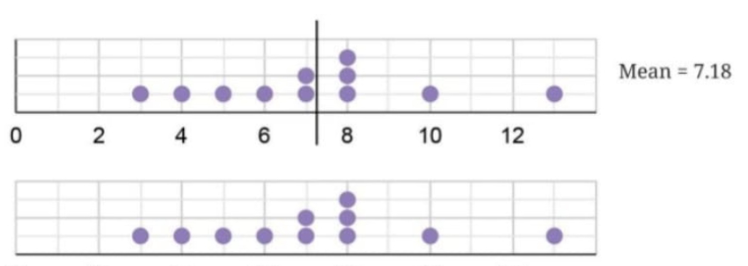 | [3]
48 | The mean of a collection of 20 numbers is 45. If every number is multiplied by 3, what will be the new mean? | [3]
49 | The data shows family sizes: 4, 5, 5, 6, 6, 6, 7, 7, 8.  - Find the mean and median.  - If a family with size 3 joins the data, what happens to the mean and median?  - If instead a family with size 10 joins, what happens to the mean and median? | [3]
50 | The mean of numbers 8, 13, 10, 4, 5, 20, y, 10 is 10.375. Find:  - The value of y.  - The median of this data.  - What happens to the mean if y is removed? | [3]
51 | The table shows the number of books read by students: 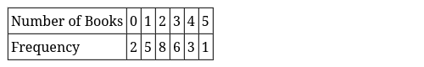  - Find the mean number of books read.  - Find the median number of books read.  - How many students are in the class? | [3]
52 | Consider the data: 10, 10, 11, 17 with mean 12.  - Show that the sum of distances on the left of 12 equals the sum of distances on the right.  - If we try 13 as a center instead of 12, show that it doesn’t balance.  - If we add a value of 8 to this data, find the new mean. | [3]
53 | The heights of 24 students were measured while wearing shoes. The average height was found to be 150.2 cm. If the shoes add 1 cm to each student’s height:  - What is the correct average height without shoes?  - Explain why you don’t need to measure all students again.  - If 2 new students join with heights 149 cm and 152 cm, what is the new average? | [3]
54 | Starting with data: 5, 7, 9, 11, 13 (mean = 9)  - Add two values such that the mean remains 9.  - Can you add three values keeping the mean at 9? Give an example.  - Add one value less than 9 and one value greater than 9 such that mean stays 9. | [3]
55 | What happens to the average if every value in the collection is doubled?  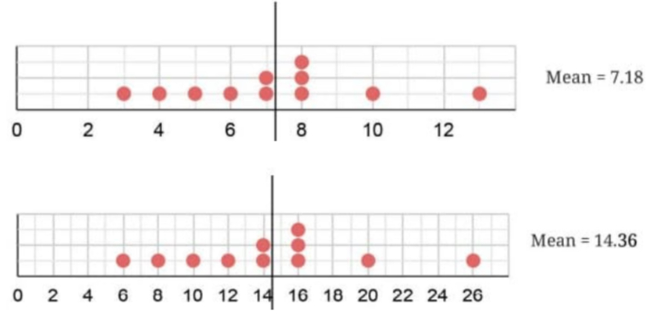 | [3]
56 | In a dataset, every value is increased by 5. Prove that the new mean is also increased by 5. | [3]
57 | In a spreadsheet, write the formula to calculate:  - The sum of cells B2 to B10  - The average of cells C5 to F5 | [3]
58 | Explain how the mean represents the ’centre’ of a collection of data. How is it different from being the midpoint of the extremes? | [5]
59 | Consider the dataset: 10, 10, 11, 17  - Find the mean and verify the balancing property  - Can there be any other value (different from the mean) such that the sum of distances on both sides is equal? Explain why or why not.  - Add a value greater than the mean. Show how the new mean increases to maintain balance.  - Add three values such that the mean remains unchanged. | [5]
60 | The weights of people in a group were measured every month. The average weight for the previous month was 65.3 kg and the median weight was 67 kg. The data for this month showed thatone person has lost 2 kg and two have gained 1 kg. What can we say about the change in mean weight and median weight this month? | [5]
61 | The average number of customers visiting a shop and the average number of customers actually purchasing items over different days of the week is shown in the table below. Visualise this data on a line graph. 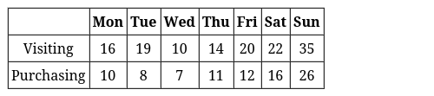 | [5]
62 | A teacher recorded the number of days students were absent in a month: 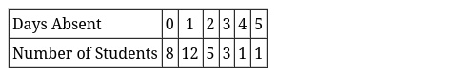  - How many students are in the class?  - Find the mean number of days absent.  - Find the median number of days absent.  - The teacher claims “Most students had good attendance.” Is this supported by the data? Justify using mean and median.  - If a new student joins who was absent for 6 days, how would this affect the mean and median? Calculate the new values. | [5]
63 | The line graph shows the average monthly temperature (°C) in a city over a year. 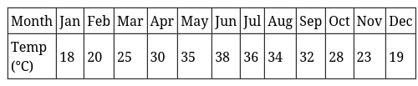  - Plot this data on a line graph  - In which month is the temperature highest? What is it?  - Identify the months when temperature is increasing  - What is the difference between the highest and lowest temperatures?  - What observations can you make about the temperature pattern? | [5]
64 | A frequency table shows family sizes in a neighbourhood. Calculate the mean and median family size. 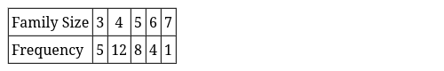 | [5]
65 | Based on the monthly maximum temperature line graph for Kerala and Punjab:  - In which month does Punjab experience its highest temperature?  - In which month does Kerala experience its lowest temperature?  - Compare the temperature variation in both states.  - Why might Kerala’s temperature remain relatively stable throughout the year? | [5]
66 | Analyze the space object launches line graph and answer:  - Approximately how many objects did the USA launch in 2024?  - Between which two consecutive years did the worldwide count increase by 2 times or more?  - What can you infer about countries not shown in the graph?  - Why is a line graph better than a clustered column graph for this data? | [5]
67 | Prove algebraically that:  - When a fixed number k is added to every value in a collection, the mean increases by k.  - When every value is multiplied by a constant c, the mean is multiplied by c.  - The average of an even number and an odd number is not a whole number. | [5]
 | Section E
68 | Read the following text carefully and answer the questions that follow:  The temperature of a city was recorded for five consecutive days. The data was arranged in a table to study changes and calculate average temperature. Data Table 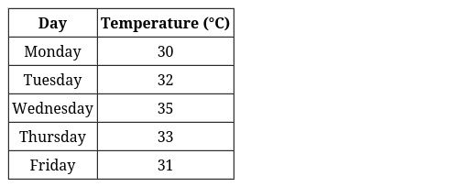  Questions:  - On which day was temperature highest? (1)  - Find the mean temperature. (1)  - Find the range of the temperatures. (2)  - OR  - If each temperature decreases by 1°C, what is the new mean? (2) | [4]
69 | The average number of days of rainfall in each month for a few cities is shown in the table below: 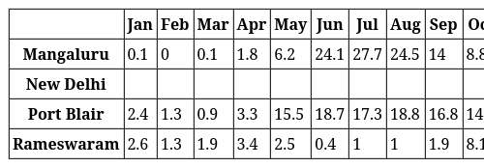  - What could be the possible method to compile this data?  - Mark the data for Mangaluru, Port Blair, and Rameswaram in the line graph shown below. You can round off the values to the nearest integer.  - 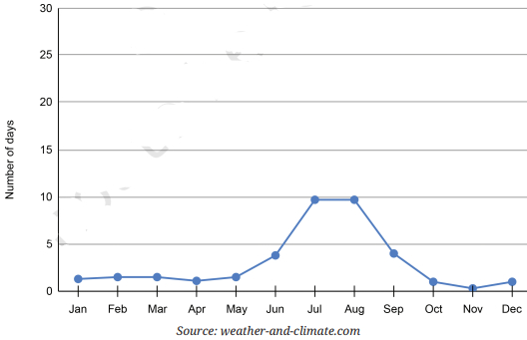  - Based on the line for New Delhi in the graph fill the data in the table.  - Which city among these receives the most number of days of rainfall per year? Which city gets the least number of days of rainfall per year?  - Looking at the table, when is the rainy season in New Delhi and Rameswaram? | [4]
70 | Read the following text carefully and answer the questions that follow:  A teacher recorded the Mathematics marks of five students in a unit test. The data was organised in tabular form to help students calculate the mean and analyse performance. By observing the table, students could easily find the total marks and average marks. Data Table 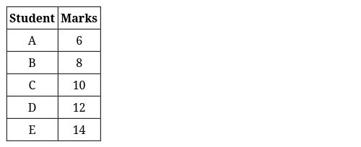  Questions:  - Find the mean of the marks. (1)  - How many students scored above the mean? (1)  - Show that the mean is the balance point. (2)  - OR  - If each student gets 2 grace marks, find the new mean. (2) | [4]

